CS 255 System Design Document Template

This template lays out all the different sections that you need to complete for Project Two. Each section has guidance to prompt your thinking. You will need to continually reference the interview transcript as you work to make sure that you are addressing your client’s needs. There is no required length for the final document. Instead the goal is to complete each section based on what your client’s needs are. Remove this note when you are finished, and replace all bracketed text with the relevant information.

UML Diagrams

UML Use Case Diagram
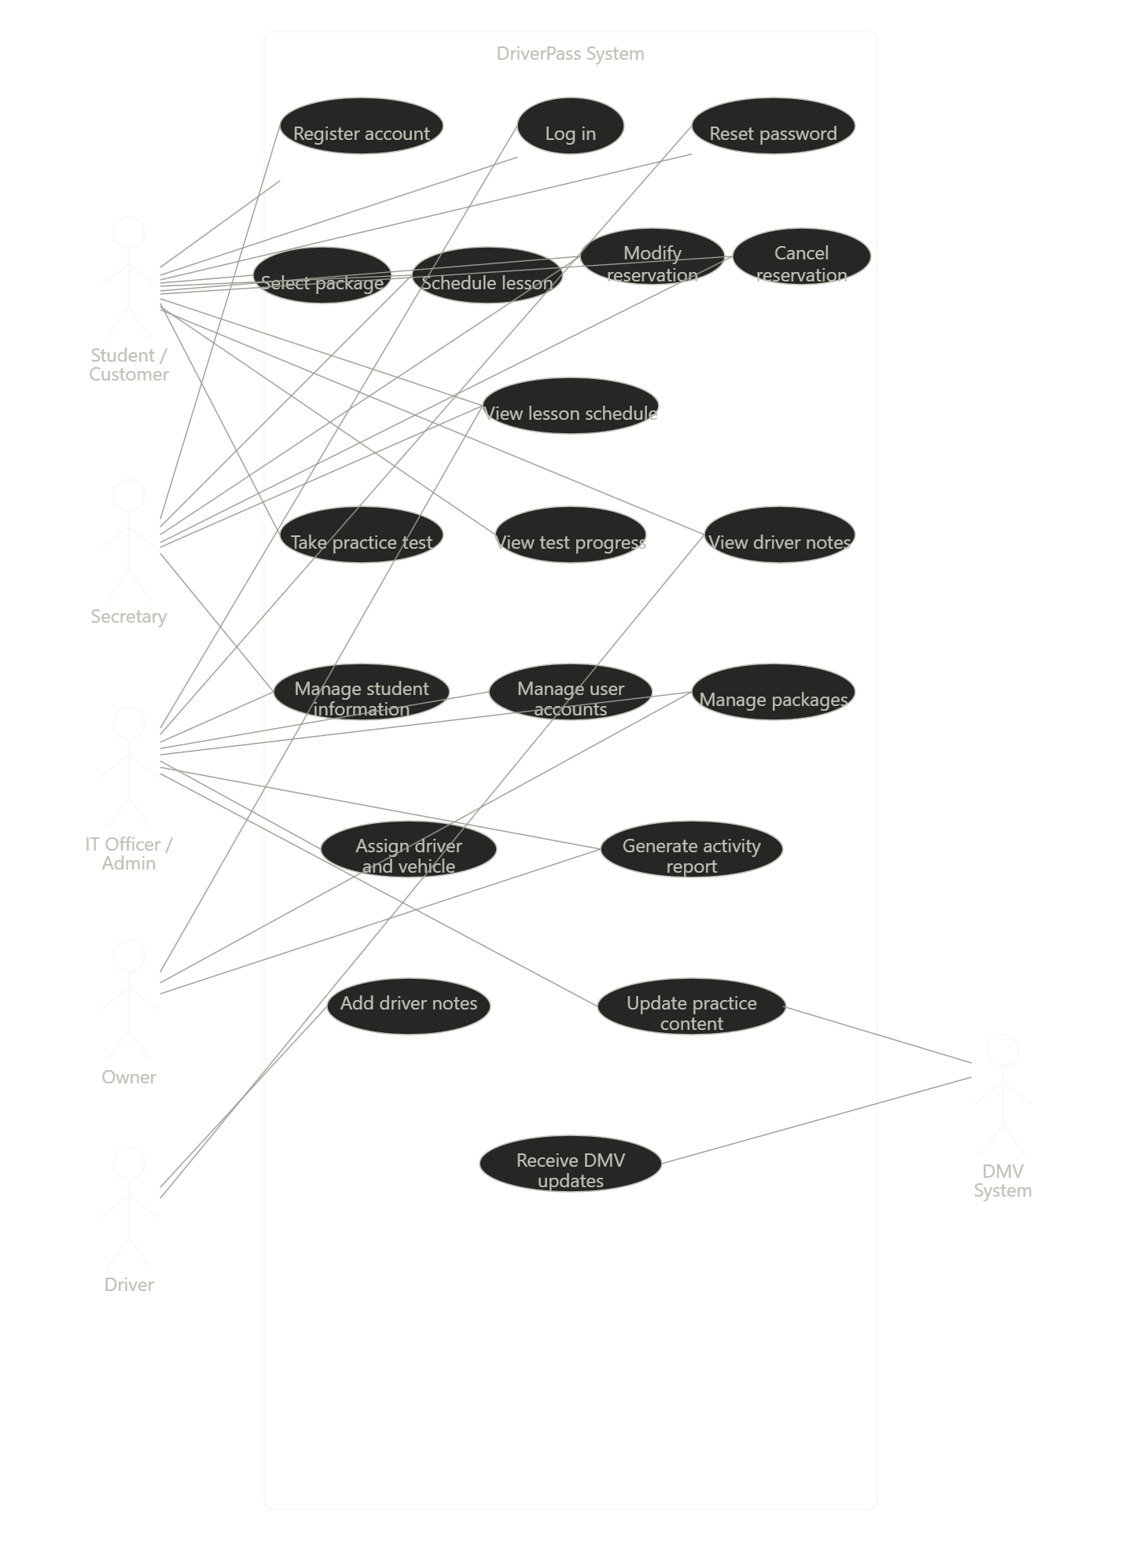

UML Activity Diagrams
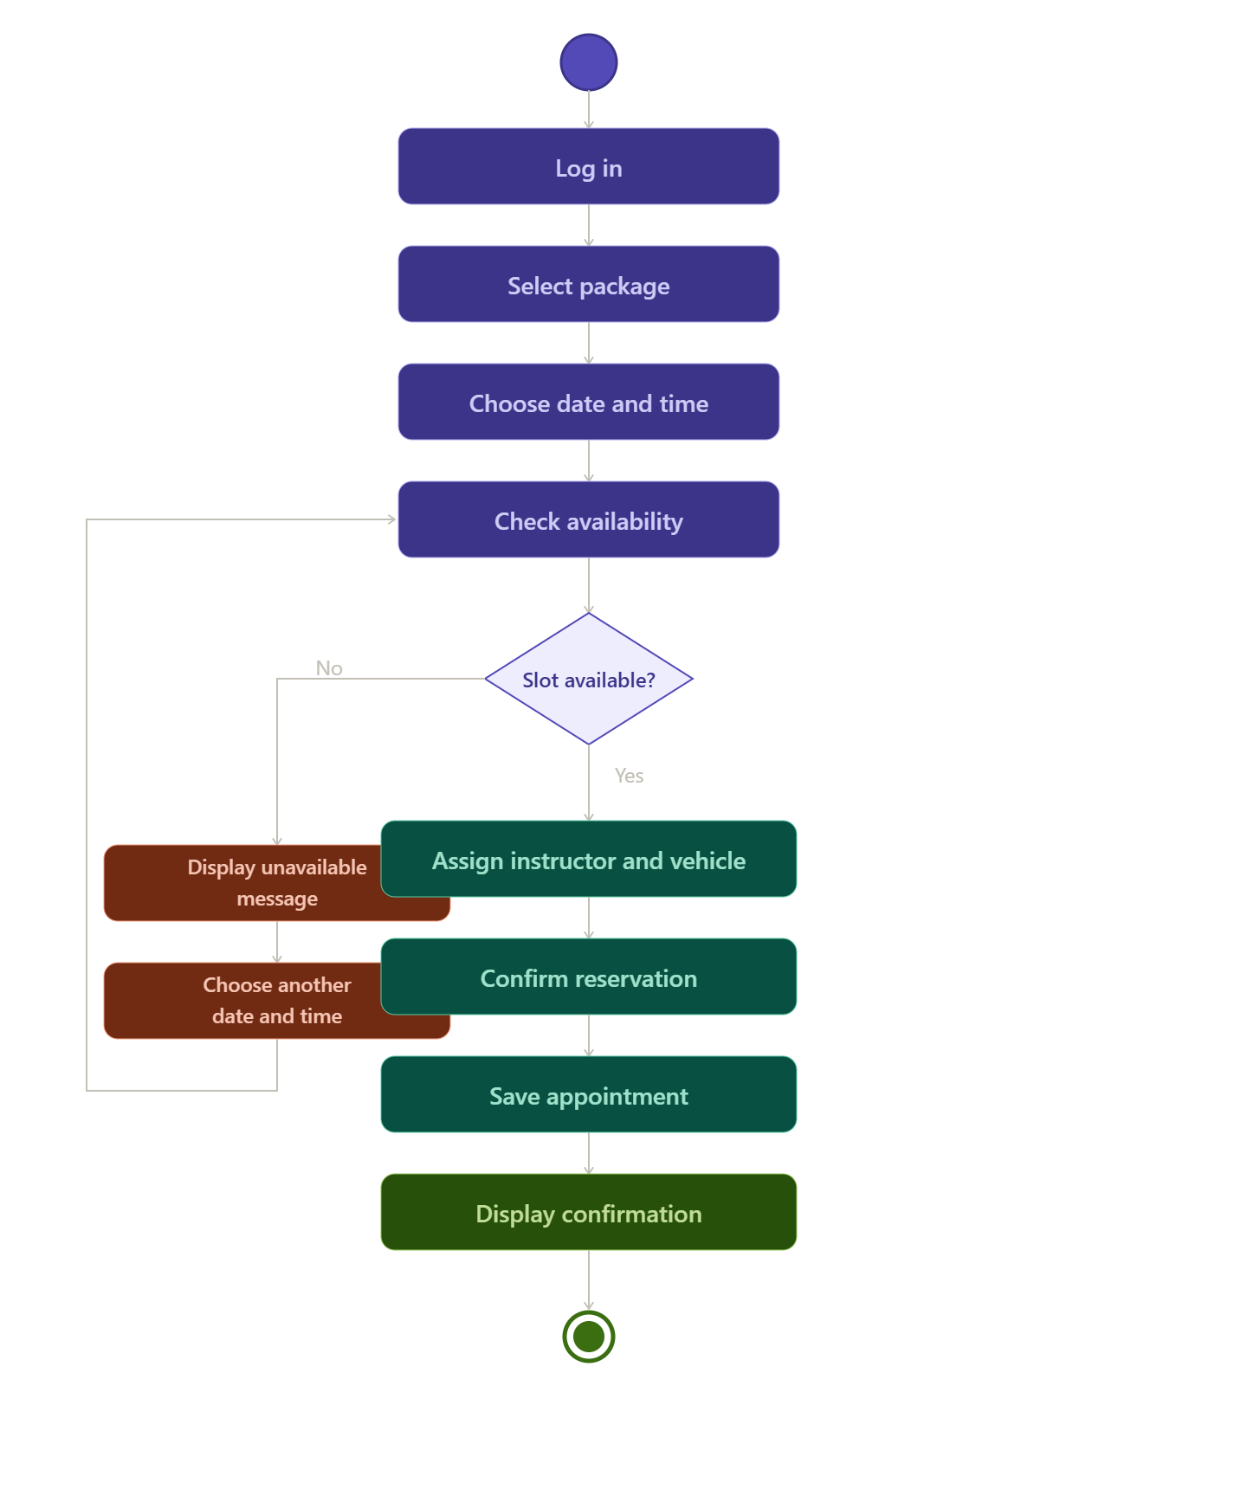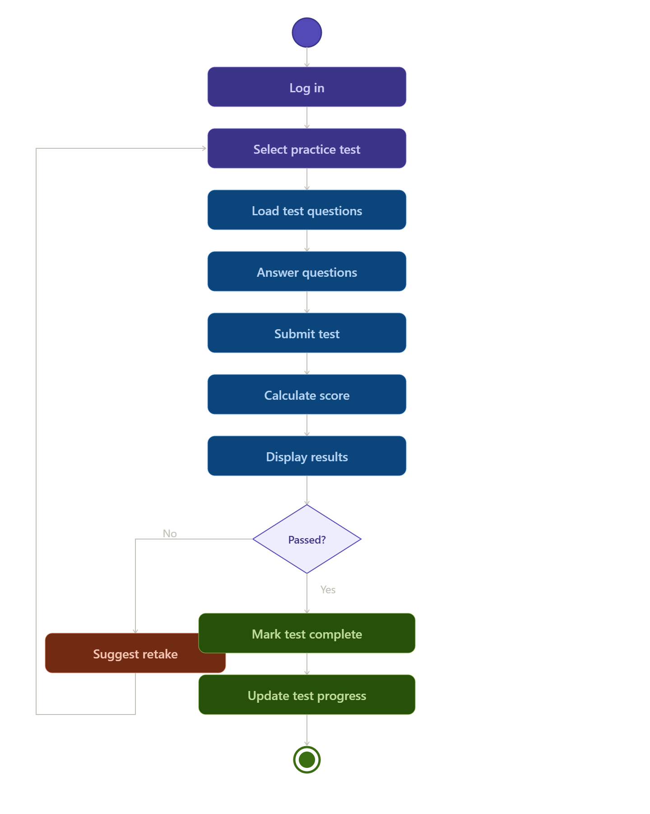

UML Sequence Diagram
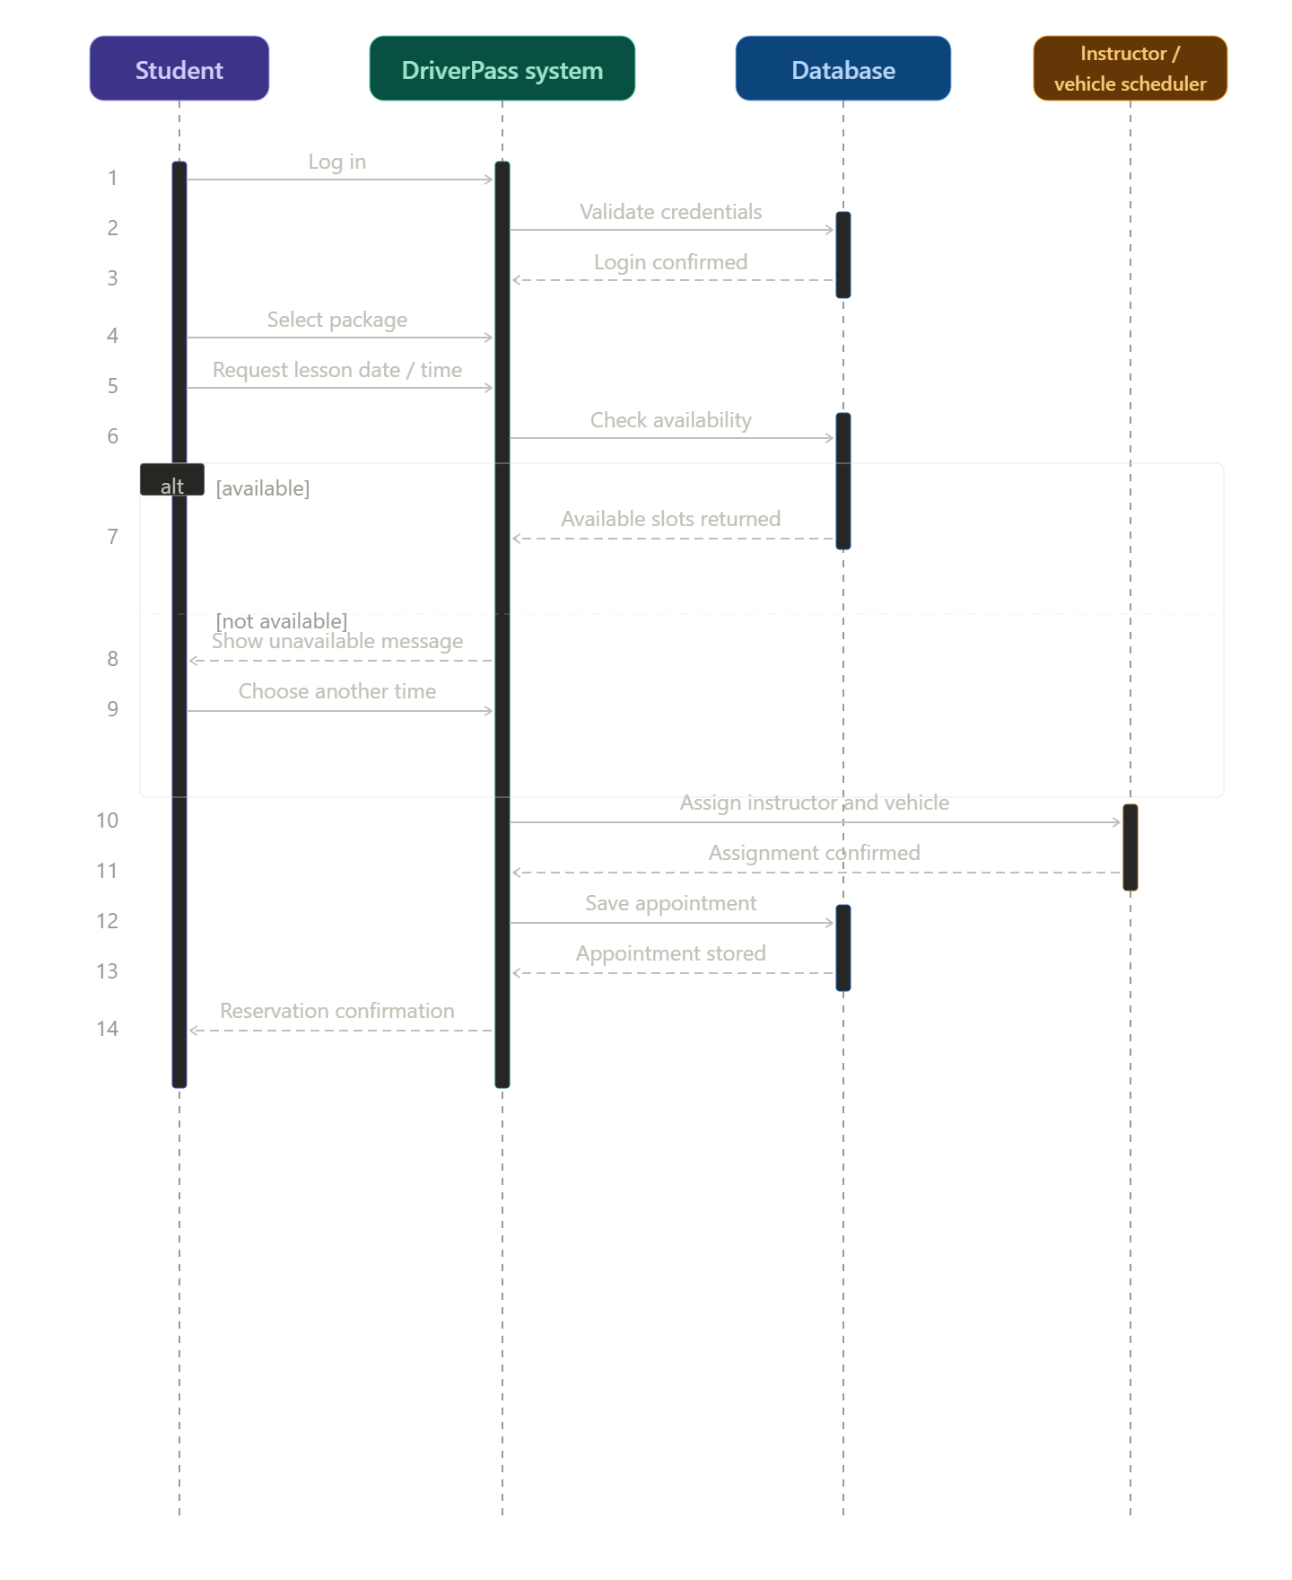

UML Class Diagram
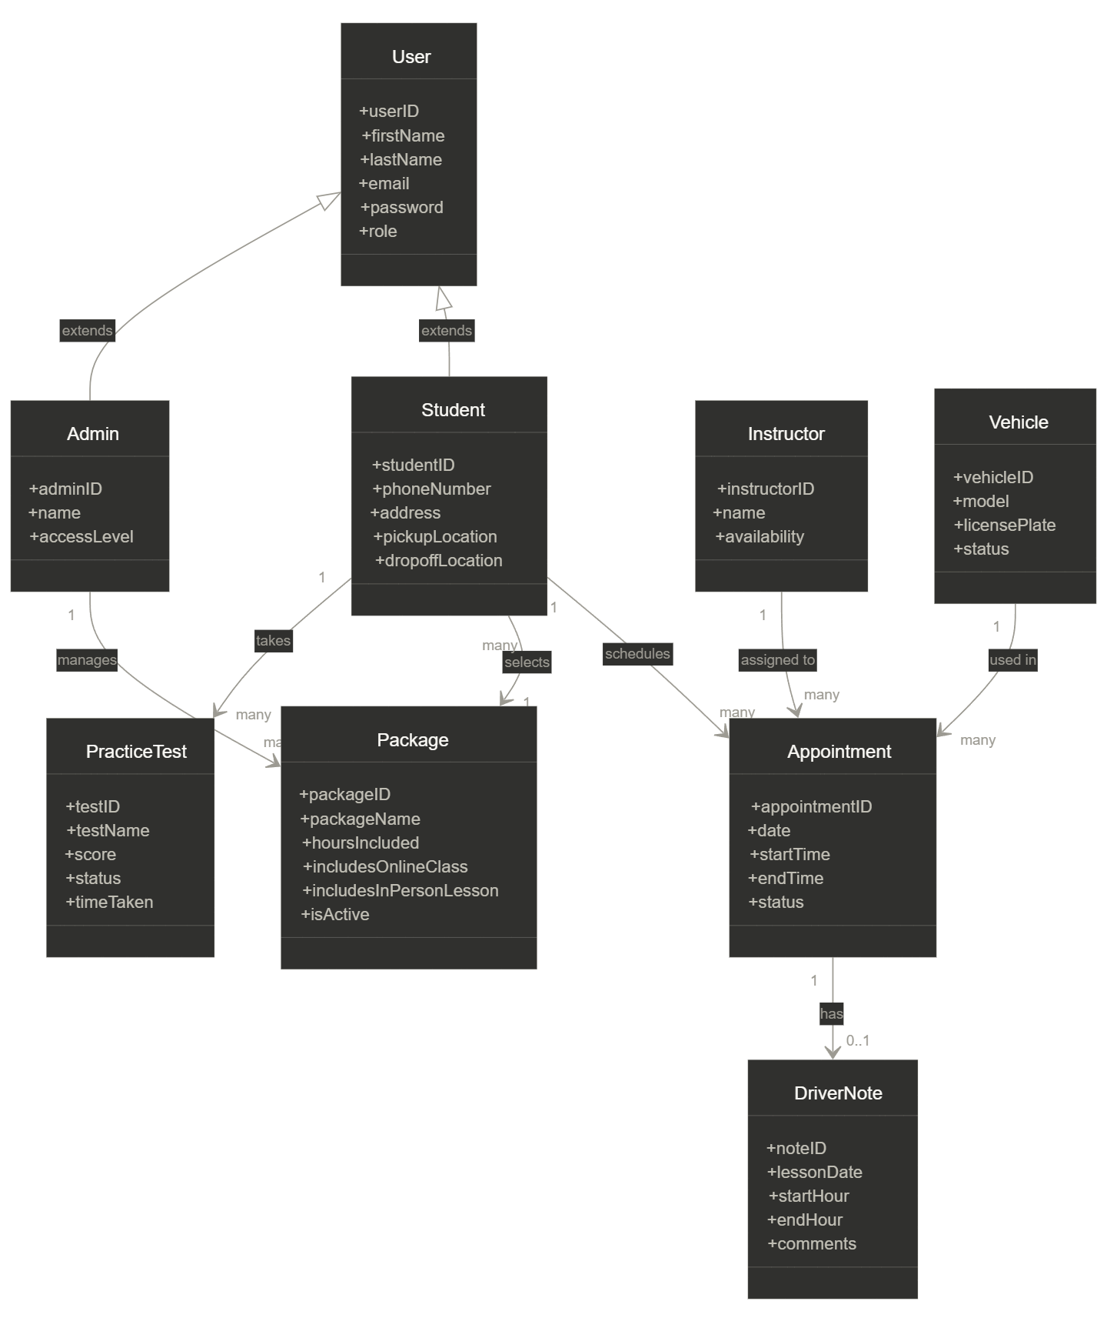

Technical Requirements
The DriverPass system will require both hardware and software components to function properly. The system will be web-based, so users will need access to a device such as a computer, tablet, or smartphone with an internet connection. The system will be hosted on a cloud-based server to allow multiple users to access it at the same time and to ensure reliability.

The system will require a database to store user accounts, lesson schedules, instructor information, and test results. It will also require secure login functionality to protect user data and ensure that only authorized users can access certain parts of the system. Different access levels will be used so that students, instructors, and administrators can only perform the actions they are allowed to.

In addition, the system will need to be integrated with external systems, such as DMV updates for practice tests. The system must also support real-time updates to prevent scheduling conflicts, such as double-booking instructors or vehicles. The system should be reliable, secure, and accessible to users across different devices.

